**Link for 3d printing design (parts):**

<http://www.thingiverse.com/thing:1247236>

All the files for 3d printing are in “Gimbal_3-axis (3d printing).zip” file.

**Required Other Components:**

1. Brushless Gimbal Motor (3)

<http://www.hobbyking.com/hobbyking/store/__42247__Quanum_2208_Precision_Brushless_Gimbal_Motor_GoPRO_size_100_200g_.html>

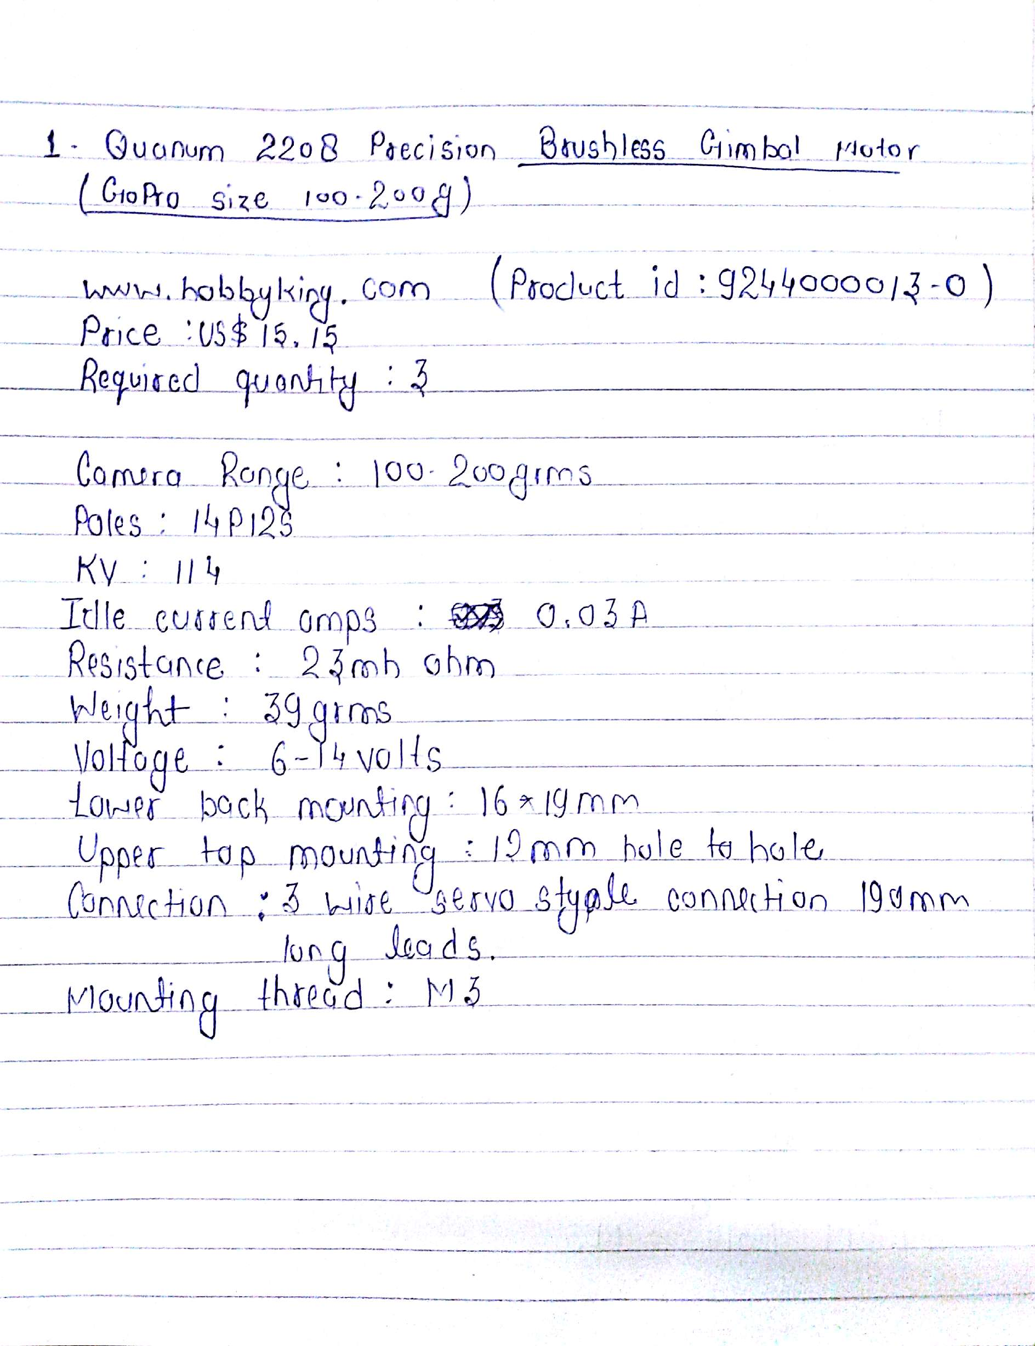

1. **Brushless Gimbal Controller (1)**

<http://www.hobbyking.com/hobbyking/store/__84191__Storm_32_3_Axis_Brushless_Gimbal_Controller.html>

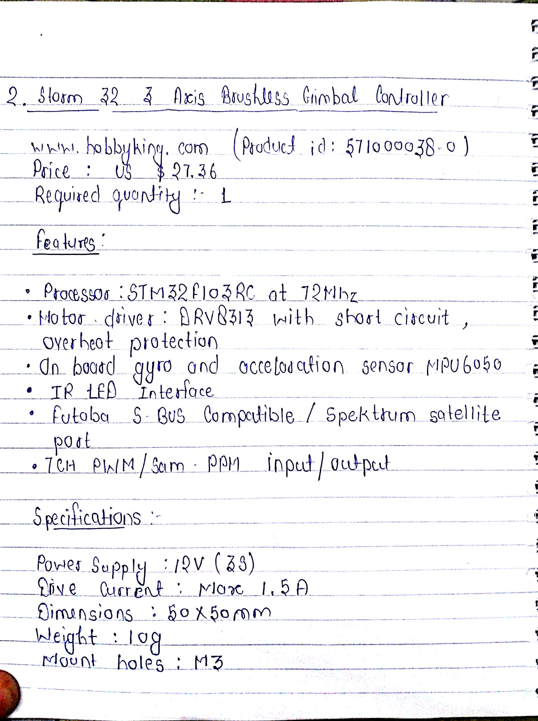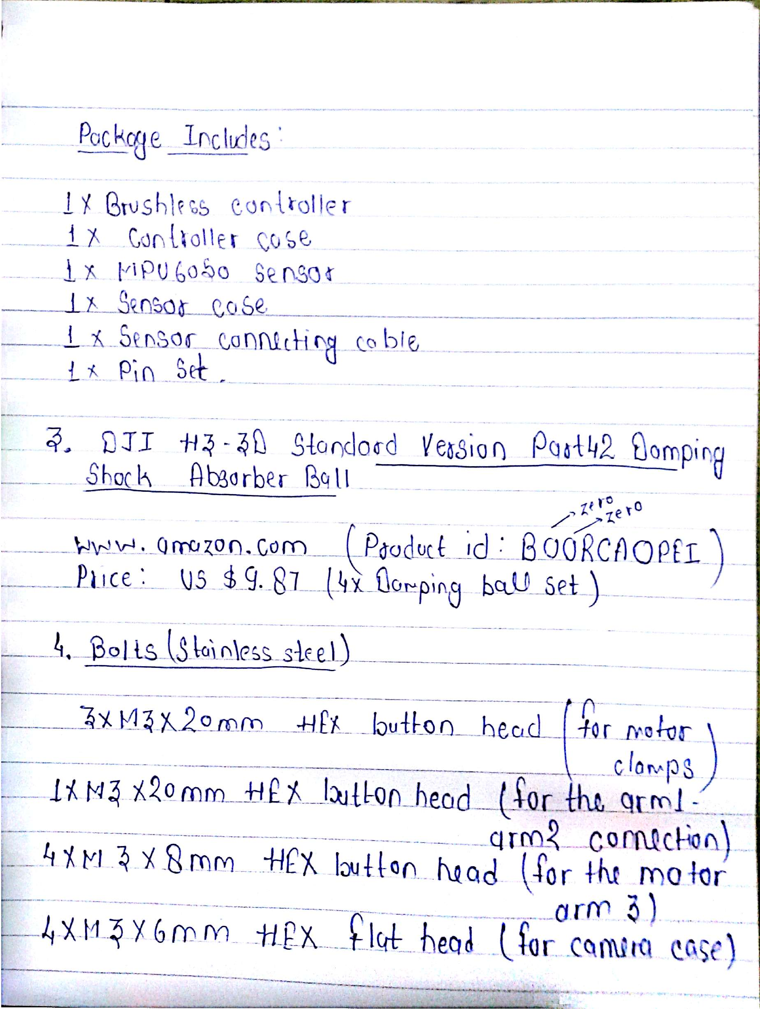

1. **Damping Shock Absorber balls (4)**

<http://www.amazon.com/DJI-Standard-Version-Damping-Absorber/dp/B00RCAOPEI>